Thursday 14th January 2021
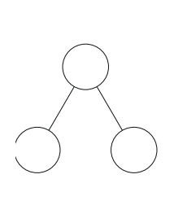
IF 5 + 3 = Then 15 + 3 =
3
5
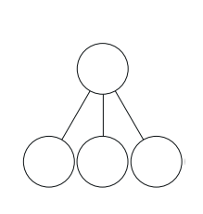
10
3
5
IF Then
5 + 3 = 8 15 + 3 =
6 + 3 = 9 16 + 3 =
4 + 2 = 6 4 + 12 =

