** 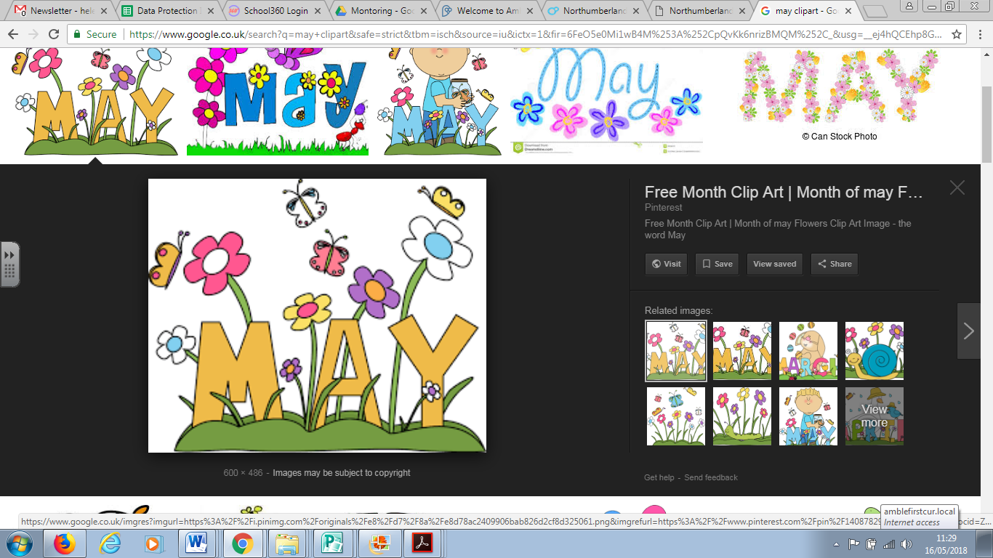

Newsletter

*At last, the sunny weather has arrived in Amble!*

*Thank you for the generous donations to our sponsored obstacle course. All the children showed great spirit and determination in order to complete the timed course and we were very proud of our medal winner who are all pictured on our website:*

[*http://www.amblefirst.northumberland.sch.uk*](http://www.amblefirst.northumberland.sch.uk)

*We raised a huge* ***£1362*** *which we will put to very good use improving our Early Years indoor environment.*

*Mrs Bruce ☺*

**Attendance awards**

Our proud pupils with 100% attendance for the month of April are:

Reception: Sophie, Max, Joe C, Archie, Cindy, Chelsea, Emma, Eva, Emilia, Jenson, Maisie, Olivia, Amelie, Joe P, Evangeline, Charlie, Arron, Logan, Lola, Isaac, Bret, Callum

Year One: Jack A, Ellie, Fleur, Jude, Ollie, Aaron F, Ruby, Charlie, Aidan, Aaron H,

Jack J, Tegan, Hannah, Harriet, Ashton, Elliot, Liam, Indie, Samantha, Ethan, Hallie, Millie, Zane, Ella-Jade, Ava

Year Two: Charlie, Liam, Jake, Jack, Meghan, Owen, Ryley, Indi, Morgan, Jackson, Ebony, Jay, Ruby

Year Three: Ava, Phoebe, Isla, Billy, Charleigh, Isaac, George, Caitlin, Callum, Savannah, Libby, Courtney, Leo, Lexie, Evan

Year Four: Megan, Lexi, Sian, Hannah G, Riley, Harrison, Myah, Jacob, Jay, Lily H, Rees, Jessica, Olivia, Harry, Grace, Hannah O, William, Rhys, Ryan, Bailey, Oscar, Liam

**Dates for your diary** 

**Parent Assemblies –** Family and friends are all welcome to watch children celebrate and share their learning – always a **Monday afternoon at 2.45pm.**

**Reception – 11th June**

**Year 1 – 18th June**

**Year 3 – 25th June**

**Year 2 – 9th July**

**Walk to school week** 

Next week (21st May) is Walk to School week. The children (Y1-4) are bringing home lots of lovely resources including a walk to school diary and some sunflower seeds to plant – all to get you walking to school! If that is not enough, we are still completing our travel trackers every day in school and those children who walk at least once a week will receive a badge at the end of each month.

 **NSPCC cake and coffee afternoon**

The NSPCC did some fantastic assemblies for the children about how to keep safe. They have now offered to come in and speak to parents about how to keep your children safe with computers, tablets and phones at home. To show our thanks we thought we could combine this event with a cake and coffee afternoon - all donations to be given to the NSPCC.

**Cake, coffee and computer safety chat- 2pm on Wednesday June 13th**

All donations of cake welcome. Teas and coffee will be served by the PTA. Children can be collected after the chat.

**E-safety**

We have recently reviewed our e-safety policy (this is on our school website) and have updated our acceptable use policy. Part of this includes all pupils and parents signing to agree to use computers, ipads and any other ICT (Information Communication Technology) responsibly and according to our rules. We have attached this to the newsletter. Please read it with your child and sign it together. On Tuesday 22nd May our teaching staff will be out in the yard to catch parents who haven’t completed the document to ensure we get consent for every pupil.

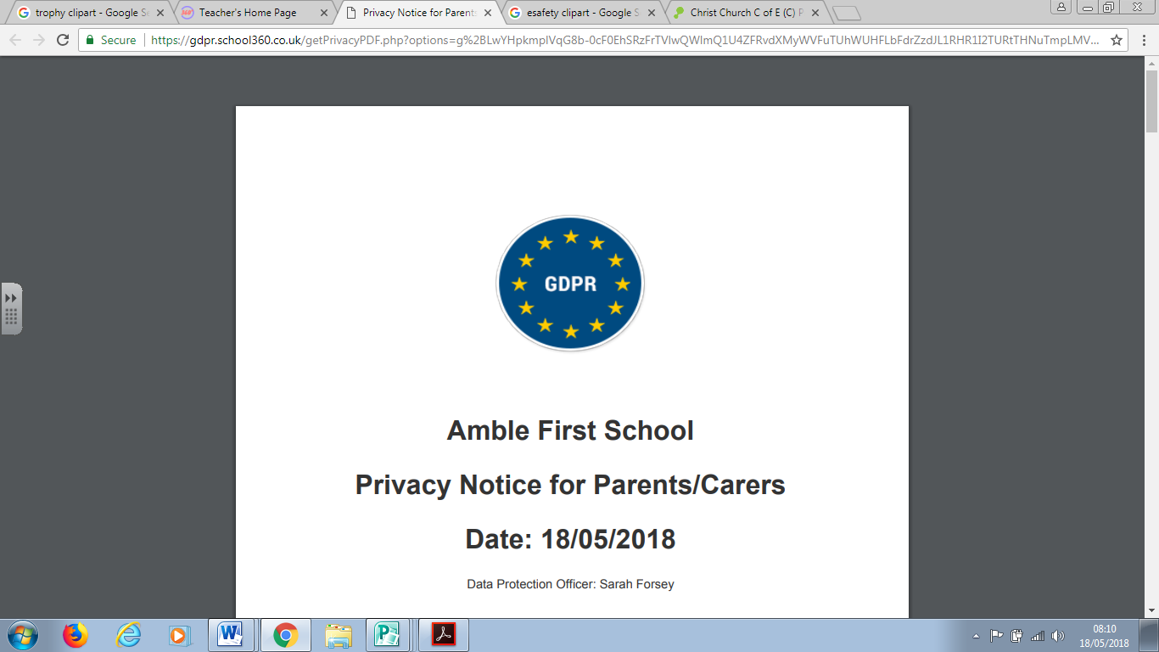**GDPR**

Also attached to this newsletter is a further letter about a new regulation that is statutory from May 25th. GDPR stands for General Data Protection Regulation. It is a European Law that gives any person or organisation a set of rules about how personal data should be stored. The letter is quite lengthy but as part of the regulation we have a duty to make sure you aware of this information and give consent for use of personal data. Please don’t hesitate to speak to Mrs Bruce or Miss Nowak if have any questions.

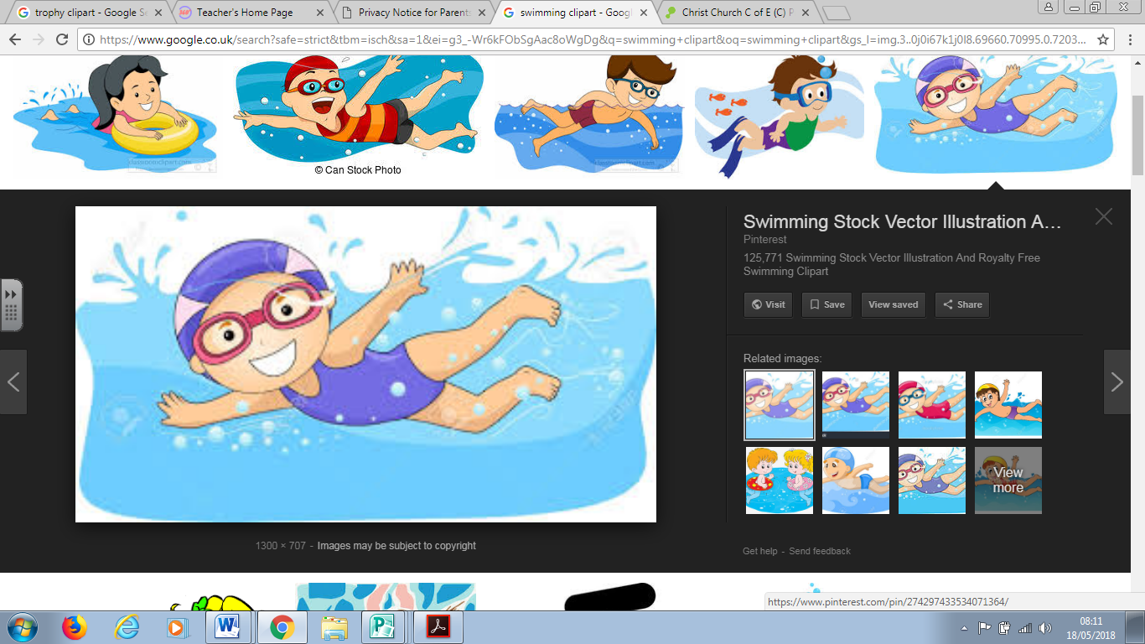**Swimming**

Swimming will finish for all children this term at the end of June. The final lesson will take place on **Tuesday 26th June** (year 4 final lesson is on 22nd May).

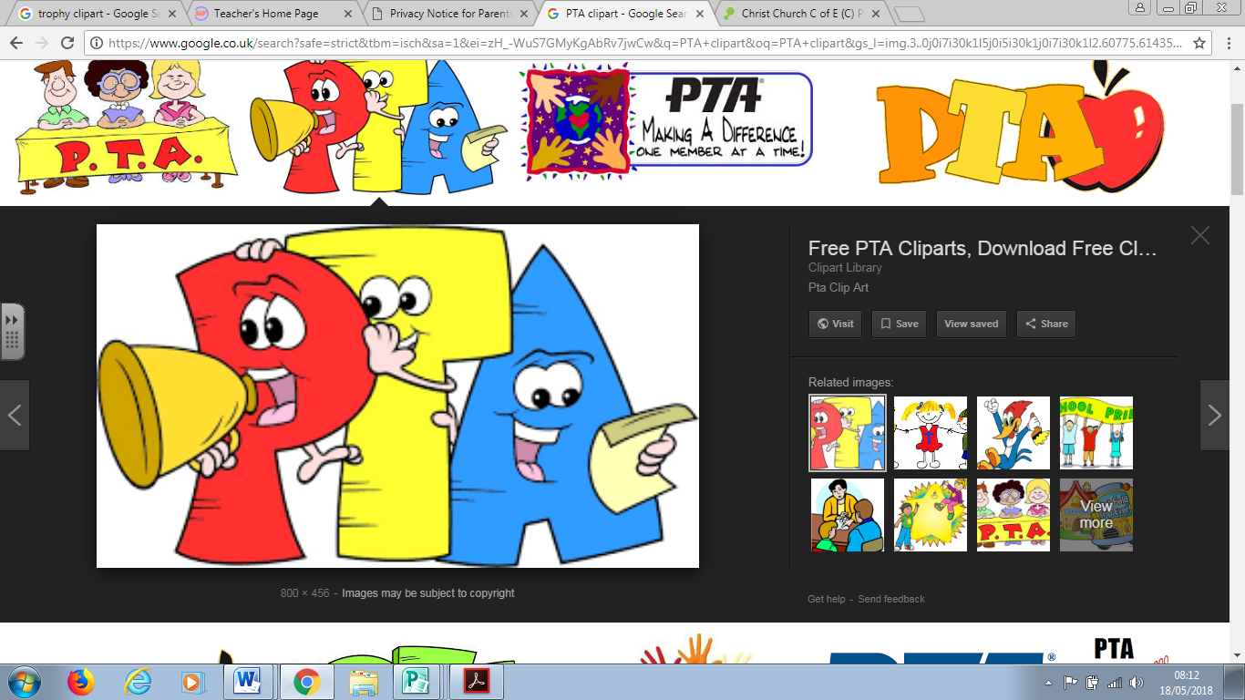**PTA**

Thanks to all the PTA staff and school staff that helped organise and run the very popular and fun Bingo night! We raised **£192**.

Don’t forget our PTA end of Term Summer disco night – **Thursday 12th July, 5:30pm- 7:00pm.** More details to follow.

**PTA Summer Fair**

We are planning our Summer Fair for **Friday July 6th at 2pm.** In the run up to this we are inviting the children to come in non- school uniform in return for a donation to our summer fair. The dates and donations are:

**Friday June 8th**- Non- uniform day in return for a donation to our chocolate and sweets stall.

**Friday June 15th**- Non- uniform day in return for a donation to our ‘smellies’ stall.

**Friday June 22nd** – Non- uniform day in return for a donation to our bottle stall.

All donations gratefully received. If you have more than one child in school, please feel free to bring one donation per family!

We are always looking for more help with the PTA. The next meeting is straight after school on **Thursday June 7th.** Even if you would just like to lend a hand with a summer fair stall, pop in and let us know.

**Transfer Day**

On **Thursday July 5th** the children will spend a day with their new teacher in their new class for September 2018. More details to follow for the children who are going to a new school. The classes for next year will be:

Reception – Mrs Donaldson

Year One – Mr Wonders

Year Two – Miss Gascoigne-Owens

Year Three- Mrs Forsey and Mrs Durham

Year Four – Miss Hunter

As we do a lot of whole school celebrations and learning together your child will already be familiar with their new teacher but if you have any concerns please see your class teacher or Mrs Bruce.

**Sports day**

On **Tuesday 10th July** we will hold Sports Day at James Calvert Spence College (middle school site), for Reception to Year 4 at 1pm. More information to follow.

**Year Four leaver assembly and awards night**

This will be held on **Thursday July 19th** at 6pm. All pupils, parents and carers are invited to attend.

Best wishes from,

**The Amble First Schoool**