L.O Can I use geographical vocabulary? ma
I can use geographical vocabulary to name physical features.
I can identify where physical features are found.
I can use the correct preposition.

Up a hill | In the river | On top of the mountain | On a cliff
On the beach | In the valley | In the forest | In the sea
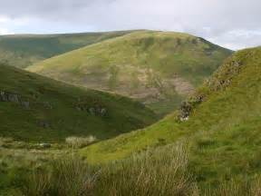
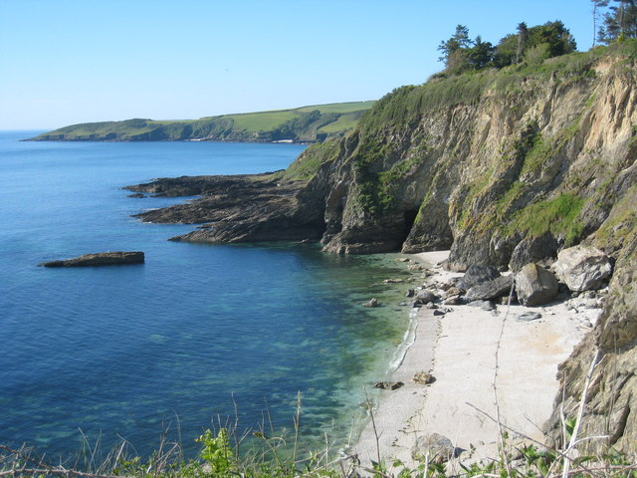
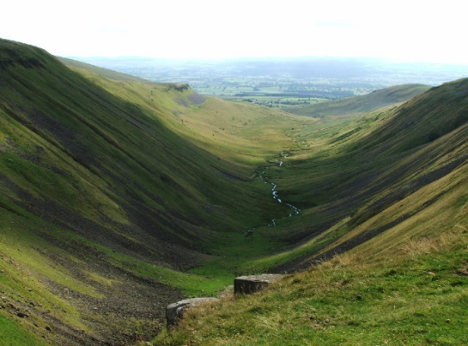
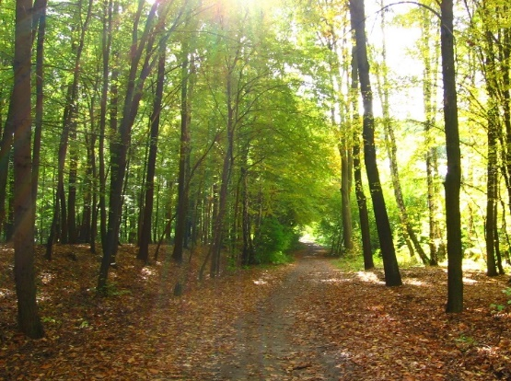
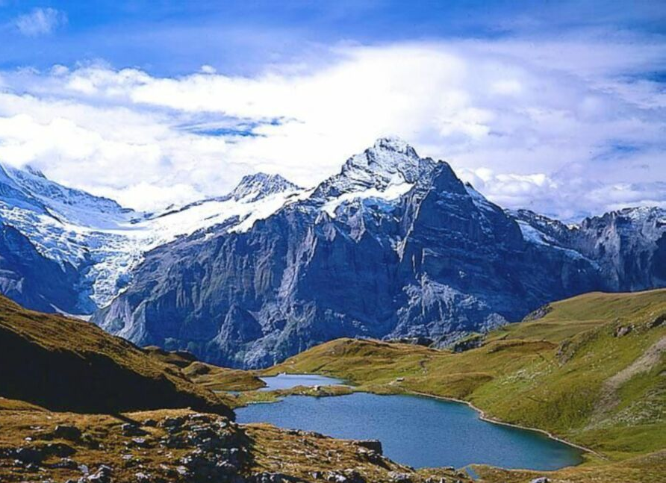

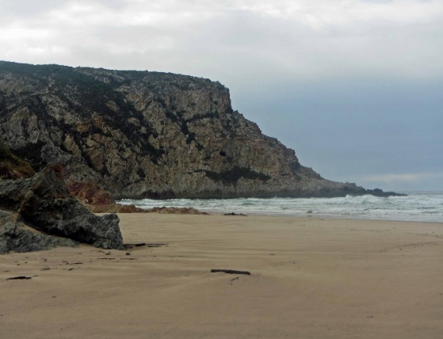
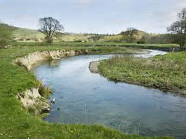
In a stream.

